Please Replace this Text with your Article Title – Title Font 14-Points Bold
Author name, Institution
Contact email – Author Font Style

Abstract
Replace this text with your abstract – Abstract Font Style. The abstract should be no longer than 300 words. The abstract should provide an overview of the full paper and should highlight the contribution which is made to the relevant body of knowledge. The font type style should be Times New Roman, size 8, with single line spacing. A 0.5in or 1.27cm indentation should be placed on both left and right sides of the text. The abstract which was accepted for the conference can be pasted into this section and formatted appropriately.
Key Words (Provide between 3 and 5 key words): Key word 1, Key word 2, Key word 3 – Keyword Font

1. Heading Level 1 (All capital letters, Times New Roman, 10 point font and Bold) – Head 1 FONT STYLE
Please replace this text with your main text – Main Text Font Style. The font type should be Times New Roman size, 9-point font, fully justified, with single line spacing.
Please leave a single line space between paragraphs – This is already set up in the Main Text Font Style. Do not indent subsequent paragraphs. Please use the built-in formatting styles where possible. These have been set up to support the formatting of the final proceedings. The formatting has been strategically designed to facilitate authors who wish to subsequently revise their articles for a journal submission based on feedback received at the conference.
The article should have a maximum word count of 3000 words. This includes only the main body of text and does not include the author information, abstract, key words, text in tables, figure and table captions, and the reference list. Note that full papers should not exceed 4000 words in total.

1.1. Heading level 2 (Times New Roman, 9-point font, bold and italics) – Head 2 Font Style

1.1.1. Heading level 3 (Times New Roman, 9-point font, italics) – Head 3 Font Styles
Please only use a maximum of three heading levels using the built-in styles. Please number each section consecutively.
For tables, please put the caption above the table and for figures please put the caption below.
Please label all tables and figures appropriately and follow APA 7th edition guidelines where possible. Examples are shown below. For tables, please avoid vertical lines where possible.
Table 1.
Sample table caption (‘Table captions’ built-in style) – Table Caption Font Style

Cohort | Sample column title | Sample column title
1st Year | Data | Data
2nd Year | Data | Data
3rd Year | Data | Data
4th Year | Data | Data
5th Year | Data | Data

Figure 1.
Sample figure caption (‘Figure captions’ built-in style) – Figure Caption Font Style
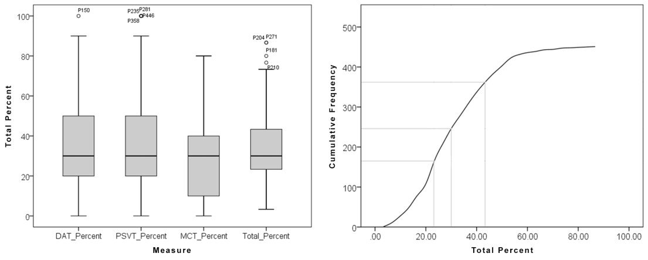

2. Article Layout
The appropriate sections for articles will vary depending on the nature and intent of the article. In general, authors should aim to provide the following information:
- Introduction: This section should provide a broad overview of the research area and serves to contextualise your research within it.
- Literature Review: +A and relevant frameworks are critiqued. It should culminate with the presentation of the need for the research presented in the current article.
- Methodology: This section should provide explicit details on the method used within the current study. Sub sections may include details of the approach, participants, methodological tools, and the implementation.
- Results: This section should provide an objective overview of the results generated from the study.
- Discussion: This section should present the authors insights into the significant of the results from the current study. The final paragraph may serve as a conclusion should the authors wish however a separate concluding section may be included.
Hierarchical lists should be listed using ‘(i) List (numbered)’ - List Numbered Font Style:
- Like this
And non-hierarchical lists should use ‘• List (bulleted)’ - List (bulleted) Font Style:
- Like this
If the authors are presenting a position paper or a discussion paper the above sections may not be suitable. In such cases care should be taken to present the article in a series of coherent sections.

3. References
Please list all references in this section in alphabetical order. Please adhere to the APA 7th Edition referencing style and use the built-in References style. Typical examples are provided below.
Davies, S. (2022). Managing curriculum change. In A. Hardy (Ed.), Debates in design and technology education (2nd ed., pp. 151-162). Routledge.
Hardy, A. (2015). What’s D&T for? Gathering and comparing the values of design and technology academics and trainee teachers. Design and Technology Education: An International Journal, 20 (2), 10-21.
Hardy, A., Dunn, A., & Trigg, R. (2021, April 27 - 30). Taking a psychometric approach to developing a tool for measuring values attributed to D&T [Paper presentation]. PATT38: Technology in our Hands, Creative Pedagogy and Ambitious Teacher Education Conference, Rauma, Finland.
McLain, M., Irving-Bell, D., Wooff, D., & Morrison-Love, D. (2019). How technology makes us human: Cultural historical roots for design and technology education. Curriculum Journal, 30(4), 464-483. https://doi.org/10.1080/09585176.2019.1649163
Morrison-Love, D. (2022). Technological problem solving: An investigation of differences associated with levels of task success. International Journal of Technology and Design Education, 32(3), 1725-1753. https://doi.org/10.1007/s10798-021-09675-5
Further Guidance Academic Writer Tutorial: Basics of Seventh Edition APA Style - Overview

